**AWT- LAB Assignment-1**Date : 16th July 2025

1)Write PHP code to display your name and the current year.

Program :

<?php

$name = "Vedant";

$currentyear = "2025";

echo "My Name is $name";

echo "The Current year is $currentyear";

?>

Output : -

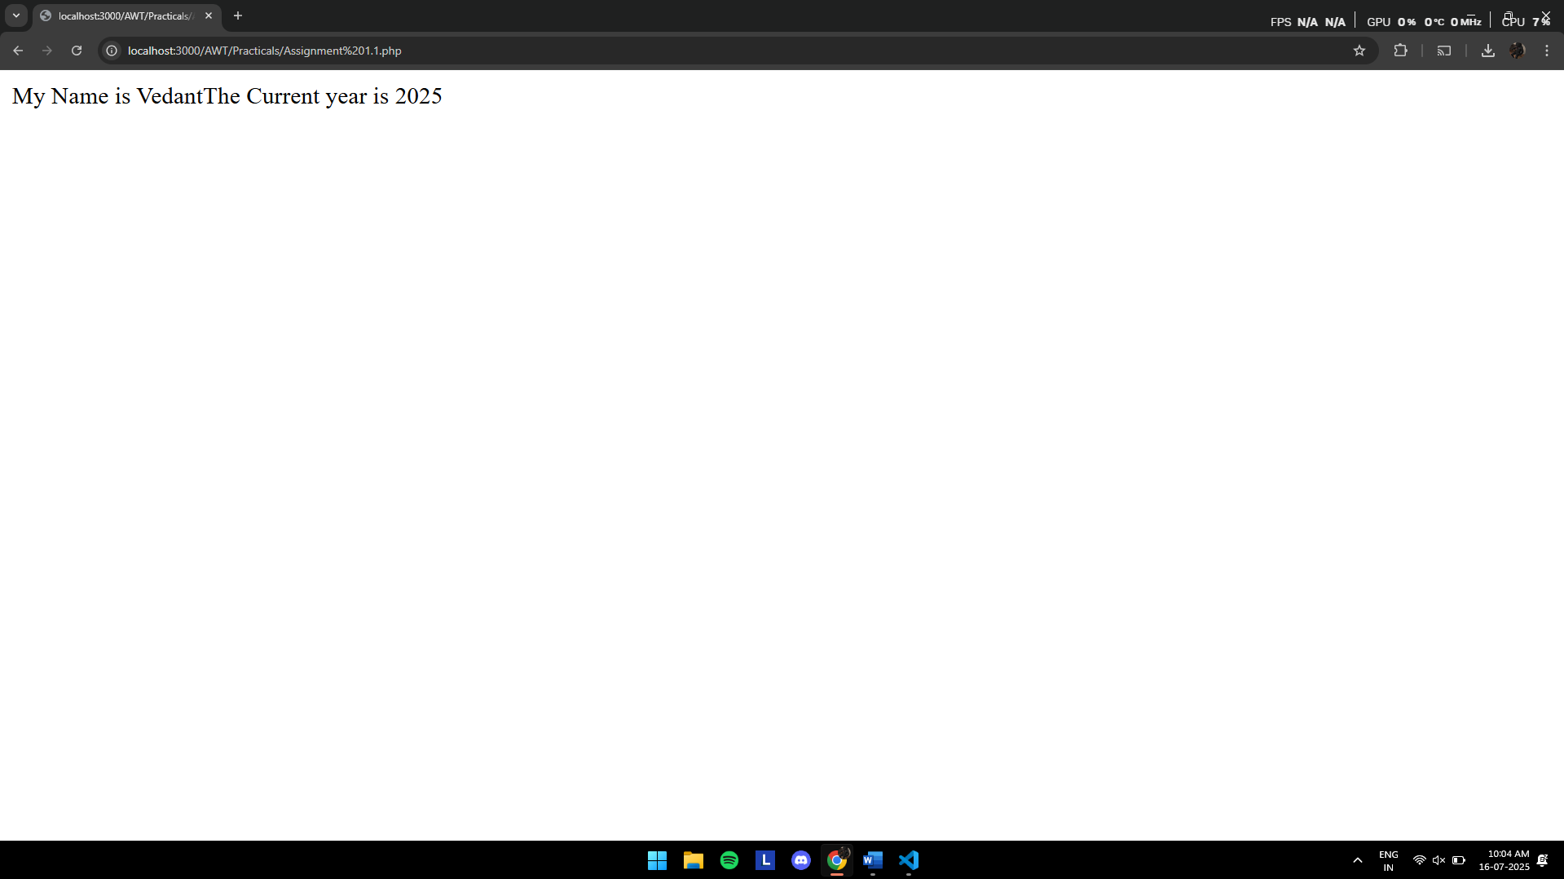

1. Write PHP code that uses single-line and multi-line comments.

Code : -

<?php

//This is the single line comment

/*

This is a

Multi Line

Comment

*/

?>

3)Use echo to print the sentence:”PHP is a server-side scripting language”

<?php

echo "PHP is a server-side scripting language";

?>

Output : 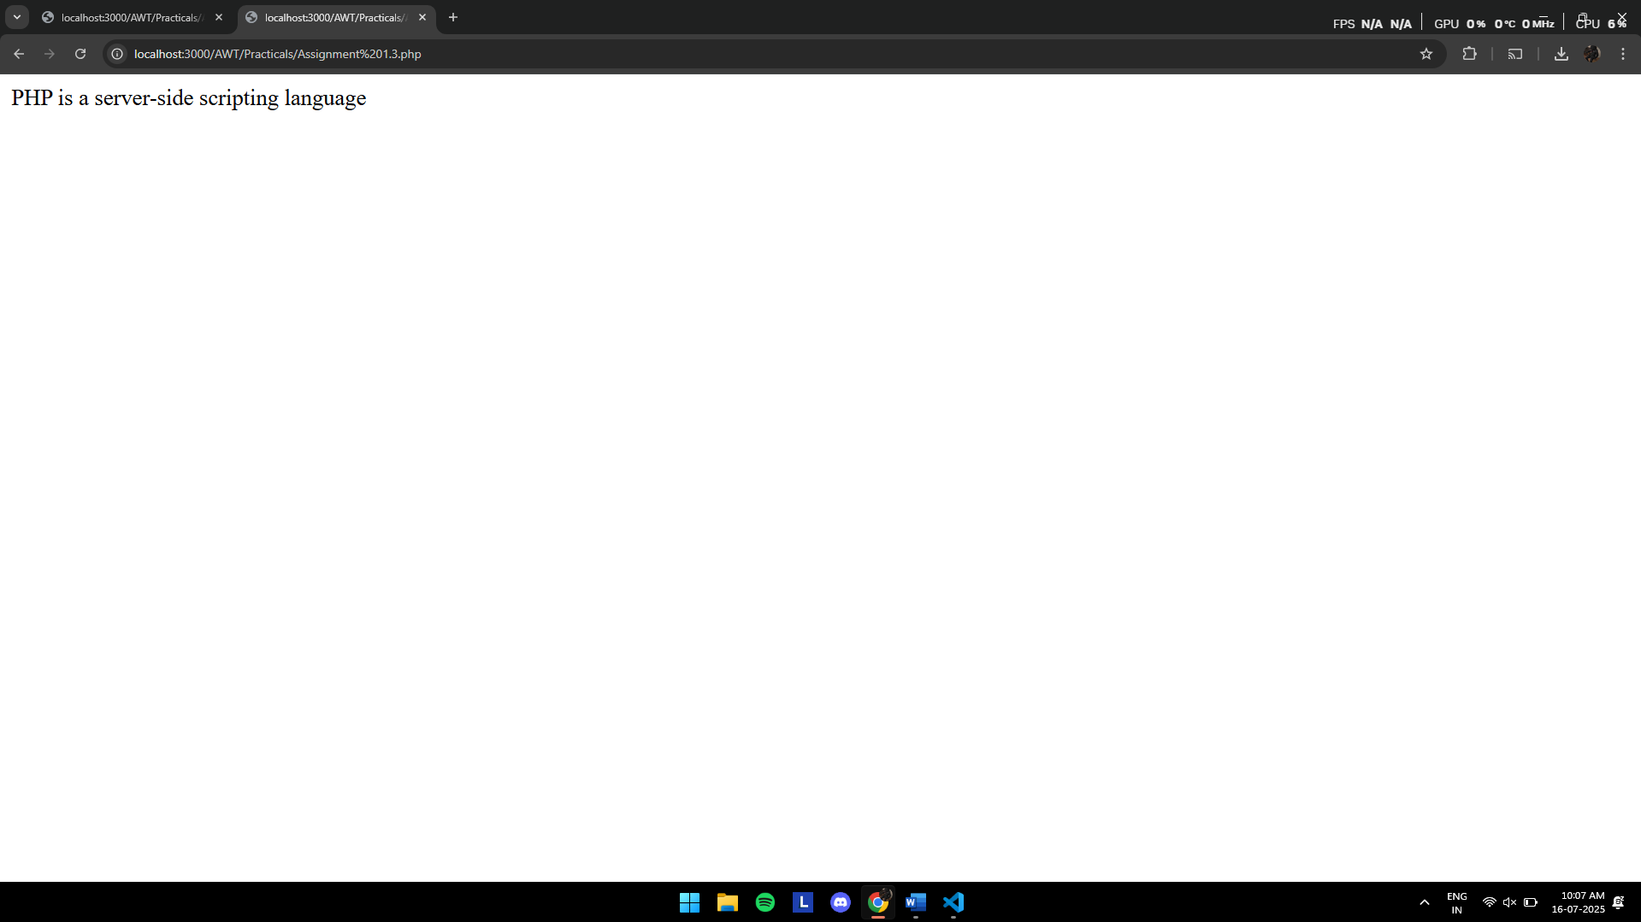

**4)Write a PHP script to calculate and display the following:**

* Sum of 10 + 5
* Product of 7 * 3
* Result of 20 / 4 + 3

Code : -

<?php

$Sum=10+5;

$Product= 7*3;

$Result = (20/5)+3;

echo "The Sum of 10+5 is = $Sum <br><br>";

echo "The Product of 7 X 3 = $Product <br><br>";

echo "The Result of 20/5 + 3 = $Result";

?>

**5) Create a PHP script called student_profile.php that does the following:**

**Define variables for:**

Student name:

Roll number:

Marks in 3 subjects:

Calculate total marks and average:

Print the student's details in a formatted output:

Code :

<?php

$Student_Name="Vedant Khedkar";

$PRN_Number= "1272240644";

$Marks_In_3_Subjects = "<br> LA = 80 <br> AWT = 90 <br> DSC = 85 ";

$Total_Marks = 80+90+85;

$Average=((80+90+85)/3)/10;

echo "Student Name = $Student_Name <br><br>";

echo "PRN = $PRN_Number <br><br>";

echo "Marks In Three Subjects : $Marks_In_3_Subjects";

echo "<br><br>Total Mark Scored : $Total_Marks";

echo "<br><br>CGPA : $Average";

?>

Output : 